Nama : Kurniawan Bagaskara

Nim : L200214253

Kelas : X

1. 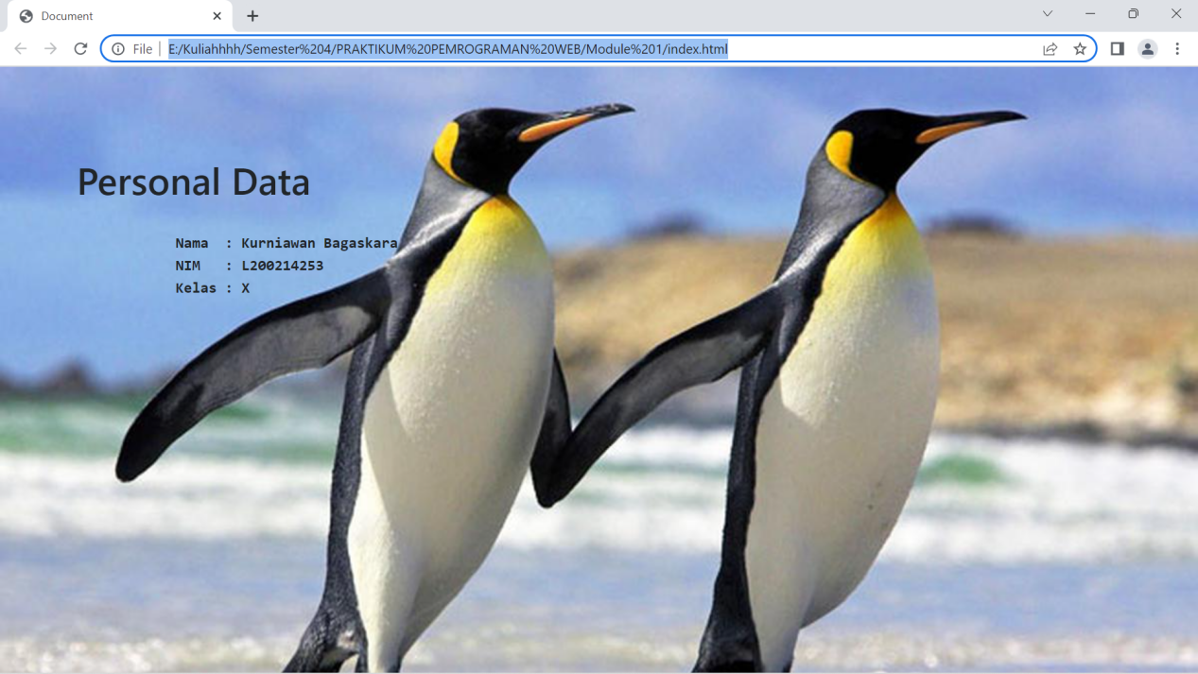

Code :

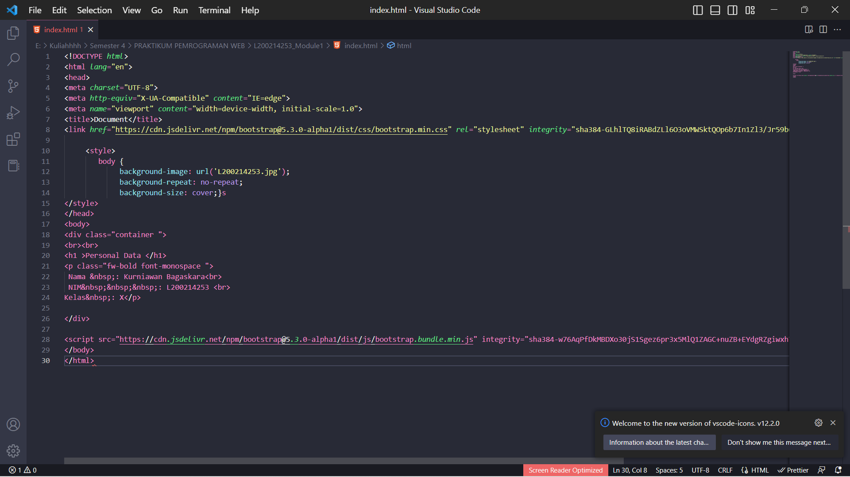

|  |  |  |
| --- | --- | --- |
| **No** | **Tag/Atribut** | **Fungsi** |
| 1 | bgcolor=’blue’ | attribute used to set the background color of a given HTML element to blue. |
| 2 | <h1> - <h6> | tags used to define six different title levels on a web page, where h1 is the most important and h6 is the lowest. |
| 3 | <font>...</font> | tags used to change the font style such as size, font type, or color in the selected text. However, this tag is no longer recommended because it has been replaced with CSS. |
| 4 | face=’verdana’ | attribute used to set the font type in the text to Verdana. |
| 5 | size=’10’ | attribute used to set the text size of a particular HTML element to 10. |
| 6 | color=’blue’ | attribute used to set the text color of a particular HTML element to blue. |
| 7 | <b> </b> | tag used to make text bold. |
| 8 | <i> </I> | tag used to make text italic |
| 9 | <u>...</u> | tag used to make text underlined. |
| 10 | <strike>...</strike> | the tag used to make the text strikethrough. |
| 11 | <sup>...</sup> | a tag used to make the text written above the normal text line like an exponent. |
| 12 | <sub>...</sub> | tag used to make the text written below the line of normal text like an index. |
| 13 | <p>...</p> | tags used to mark the beginning and end of a paragraph. |
| 14 | align=’center’ | attribute used to set the position of a particular HTML element in the middle of the page |
| 15 | <img> | the tag used to display an image on a web page. |
| 16 | src=’gambar.jpg’ | attribute used to specify the location or URL of the image to be displayed. |
| 17 | width=’100’ | attribute used to set the image width to 100 pixels. |
| 18 | height=’100’ | attribute used to set the image height to 100 pixels. |
| 19 | alt=’alt’ | attribute used to provide an alternative description of the image, which will appear if the image cannot be displayed. |
| 20 | <ul>...</ul> | tag used to create an unordered list. |
| 21 | <ol>...</ol> | tag used to create an ordered list. |
| 22 | <li>...</li> | tags used to mark each item in the list. |
| 23 | type=’circle’ | attribute used to specify the type of bullet in an unordered list. |
| 24 | <table>...</table> | tag used to create a table on a web page. |
| 25 | <tr>...</tr> | tag used to mark each row in the table. |
| 26 | <td>...</td> | tag used to mark each cell in the table. |
| 27 | border=’2px’ | attribute used to set the width of the border on the table |
| 28 | colspan=’2’ | to combine 2 columns |
| 29 | rowspan=’2’ | to merge 2 rows |
| 30 | </BR> | to break the line |